Characterization of Trailing Back-up Element Placement
An explanation of how the components of secondary element placement affect min. engagement speed, magnitude, and the rate of engagement.
By: Curtis Stephens
05/02/2023

Introduction:

Why secondary element placement matters: (PDC’s and Knuckles)
The components of element placement affect min. engagement speed, magnitude of engagement, and the rate of engagement.

Why back-up elements are used:
- Prevent DBR - When underexposed trailing back-up cutters engage, they tend to pack off due to lack of space to efficiently evacuate cuttings. When the primary cutters wear beyond a predetermined point, or fail, the secondary elements begin to work. These elements increase torque and decrease ROP, signaling the driller to pull the bit before a potential DBR.
- Limit ROP – Typically used to improve steerability when sliding, reduce straight hole deviation, or prevent primary cutters from overload (to crush or shear the element).
- Increase diamond density – Working or active back-up cutters increase bit durability at the cost of ROP.

Project Goal:
Plot a graph that compares (bits) the minimum engagement speed, magnitude, and rate of engagement of back-up elements.
The graph will plot ft/hr per 100 rpm (a variant of IPR) on the Y-axis and Σ volume of material removal on the X-axis.

Understanding how elements (PDC’s and Knuckles) interact with the rock:

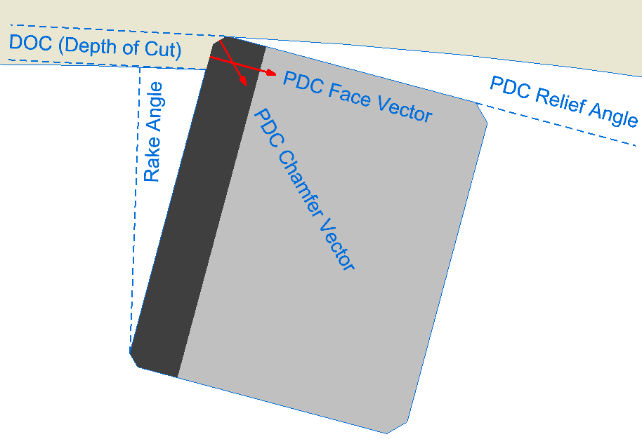
PDC Engagement with the rock:
As DOC (Depth of Cut) increases the chamfer of the PDC engages the rock first, then the face of the PDC engages. The face of the PDC is more efficient at shearing when compared to the chamfer. However, the force vector of the chamfer increases compression on the diamond, which in return increases the amount of tangential force (predominantly torque) required to exceed the element’s yield strength (to crush or shear the element). There is a delicate balance in this trade-off. And there are infinitely more variables that influence this balance when you consider drilling parameters, BHA, or the properties of the PDC itself.

Helical POM (Path of Motion):
When drilling, any cutter’s POM resembles a helix.
There are two variables that define this helix:
- Radius - As the radius increases the helix angle decreases.
- IPR (Inch per rev.) - As IPR increases the helix angle increases.
  - IPR = ft/hr * rpm * 0.2 (IPR = ft/hr * 12in / 60 minutes / rpm)
As the helix angle increases, the effective rake angle (relative to POM) of the element decreases.

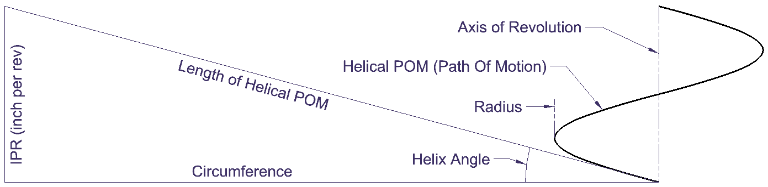

The Role of Cutlet Plots in Bit Design:
Cutlets are the portions of each element (PDC or knuckle) that do work at a given IPR.
Cutlets simulate drilling as a revolved projection (2D plot) at any given IPR.
- The cutlet area and centroid determine the volume of rock each cutlet interacts with.
  - The orientation of each element (relative to POM) determines the direction in which forces are applied to each cutlet.
    - By applying a tangential psi to each cutlet (the yield strength of a given rock), you can calculate the component forces applied to each cutlet: tangential, axial, and radial (relative to the bit body).
      - The sum of these forces can predict WOB, Torque, and the magnitude and direction of the lateral force acting on a bit.
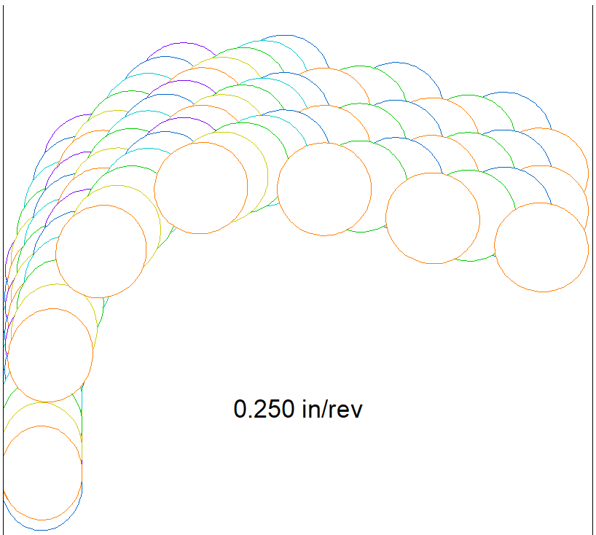
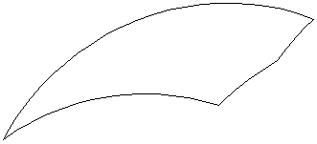

Cutlet plots are two-dimensional representations of a complex three-dimensional drilling process. This simplification may not always provide an accurate representation of real-world drilling scenarios. The analysis of cutlet plots relies on certain assumptions, such as constant rock properties and uniform stress distribution. In practice, these conditions can vary significantly, affecting the accuracy of the results.

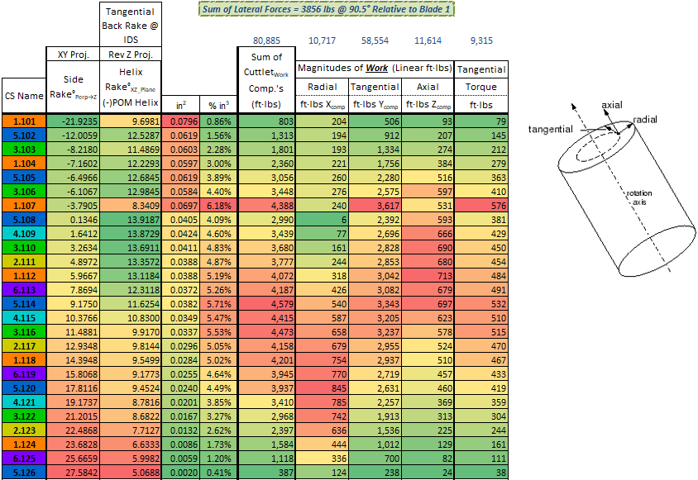
Understanding how back-up elements (PDC’s and Knuckles) interact with the rock:

Define the components of secondary element placement:
- Radial Tip offset - The distance between the largest radial point on the pri. and sec. elements.
- Z Tip offset - The distance between the tip height of the pri. and sec. elements (parallel to the axis of revolution).
- Degrees trailing - The number of degrees the sec. element trails behind its pri. element.
- Element diameters - The diameters of the pri. and sec. elements.
- Element vectors - The vectors run parallel to the cylinder of the pri. and sec. elements (a combination of tilt and back-rake).

A revolved projection of Pri. and Sec. elements @ 0.000 IPR
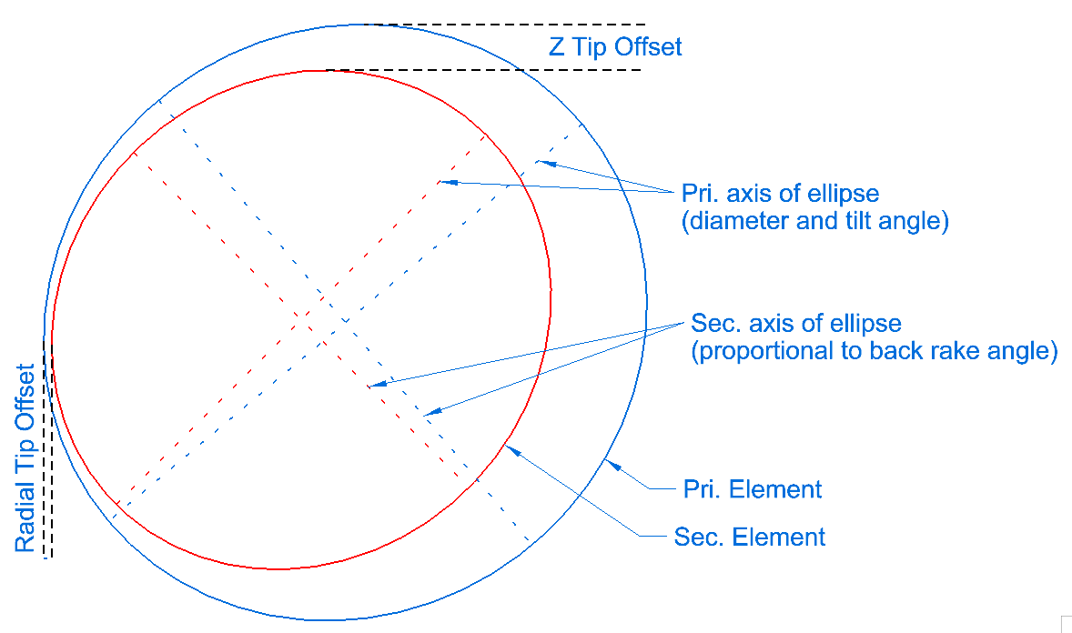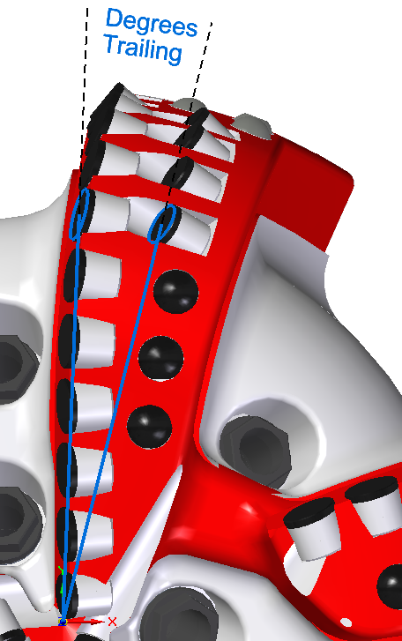

How the components of sec. element placement affect min. engagement speed, magnitude, and the rate of engagement:
Note: The statements indicate how the components behave in isolation (single variable testing).
- Radial Tip offset – Decreasing this value: (shifts the cutlet’s centroid outwards radially)
  - Min. engagement speed: Decreases
  - Magnitude of engagement: Increases
  - Rate of engagement: Decreases
- Z Tip offset – Increasing this value: (shifts the cutlet parallel to the axis of revolution)
  - Min. engagement speed: Increases
  - Magnitude of engagement: Decreases
  - Rate of engagement: Not directly affected
- Degrees trailing – Increasing this value: (Caused the bit to be more sensitive to changes in IPR)
  - Min. engagement speed: Decreases
  - Magnitude of engagement: Increases
  - Rate of engagement: Increases
- Element diameters – As the diameter of the sec. to pri. elements decrease: (Sec. elements are smaller)
  - Min. engagement speed: Not directly affected
  - Magnitude of engagement: Decreases
  - Rate of engagement: Decreases
- Element vectors – These resultant vectors are based on the successive rotations of tilt and back rake. (These values shift the location of the cutlet centroid in combination radial tip offset and the element diameters)

The effects of back-up element engagement on the pri. elements:
When sec. elements engage, there is a redistribution of the input forces (WOB and torque) exerted on each cutlet.
As the sec. elements do more work: (Assuming input forces remain constant)
- The number of working elements increase (Increased bit durability)
  - The forces exerted on the pri. elements decrease (likely to increase footage - dependent on cutter failure mechanism)
    - Reduced risk of pri. element overload (Crushed elements – the result of exceeding the element’s yield strength)
- Instantaneous ROP decreases (Which doesn’t necessarily translate to reduced overall ROP)
When knuckles engage, they limit ROP. Typically, this compromise made to improve steerability when sliding, reduce straight hole deviation, or prevent primary cutters from overload.

Engagement Graphs:

A visual representation of engagement behavior plotted over IPR.

Definitions, Abbreviations and Acronyms:
Definitions, Abbreviations, and Acronyms:
- JSA - Junk Slot Area

